**AN ENGINEERING PROJECT REPORT**

On

**ELECTRICITY BILLING SYSTEM**

**Submitted By**

**ATUL POKHAREL** (170308)

**NABIN RAJ DHUNGEL** (170322)

**NABIN JOSHI**  (170323)

**RAKSHYA BHETWAL** (170334)

Under the supervision of

**…………………**

**Submitted To**

**The Department of IT and Computer Engineering**

**In Partial fulfillment of requirement for the degree of**

**Bachelor of Engineering in Computer.**



**Cosmos College of Management & Technology**

**(Affiliated to Pokhara University)**

**Tutepani, Lalitpur, Nepal**

**Date …….**

**Abstract**

Our project basically deals with the developing of an application EBS (Electricity Billing System). The Electricity Billing System is an executive information system that could be used for entering, calculating, and monitoring the billing details of the electricity units consumed by the consumers.it provides an environment to maintain the consumers details starting from receiving electricity bills, viewing the due date or even extending as per their wish, doing required payments, file up complaints regarding the billing system and performance information to the management.

It would be an Internet based or Web-based application that would ensure timely availability of status parameters. With the help of this project consumers need not go to electricity association office physically to pay their electricity consumption bill but they can perform all these tasks by just staying in home. The aim is to automate the existing manual system by the help of computerized equipment’s and computer software, fulfilling their requirements, so that their valuable data can be stored for longer period of time with easy access and manipulation of the same. Basically, this project describes how to manage for good performances and better services for the best.

**Keywords: EBS, NEA**

**Table of Content**

1. INTRODUCTION 2

**1.0 BACKGROUND** 2

**1.1 PROBLEM STATEMENT** 3

**1.2** **OBJECTIVES** 3

**1.3** **SCOPE** 4

**1.4** **EBS APP REQUIREMENTS** 5

**1.4.1 Hardware Requirements** 5

**1.4.2 Software Tools** 5

2. LITERATURE REVIEW 6

**2.0 THEORETICAL FRAMEWORK** 6

**2.1 INTRODUCTION** 7

**2.2 TYPES OF SYSTEM** 7

➢ **Manual System:** 7

➢ **Current System** 7

➢ **Existing System** 8

**2.4 DISADVANTAGES OF EARLIER USED SYSTEM** 11

**2.4.1. MANUAL SYSTEM** 11

**2.4.2. EXISTING SIMILAR SYSTEMS** 11

**2.5 ADVANTAGES OF PROPOSED SYSTEM** 12

3. METHODOLOGY 13

**3.0 INTRODUCTION** 13

**3.1 SYSTEM DESIGN** 13

**3.1.1 DATA FLOW DIAGRAM** 13

**3.1.2 USE CASE DIAGRAM** 15

**3.1.3 ER DIAGRAM** 16

4. WORK PROGRESS 18

**4.0 Work Completed** 18

**4.0.1 Snapshots** 18

**4.1 Work to be done:** 20

5. WORK SCHEDULE 21

6. REFERENCES 22

**Table of Figures**

Figure 1: Theoretical Framework 6

Figure 2: NEA 8

Figure 3: ESEWA 9

Figure 4: Khalti 10

Figure 5: Data Flow Diagram 14

Figure 6: Use Case Diagram 15

Figure 7: ER Diagram 17

Figure 8: Login / Signup Page 18

Figure 9: Homepage of Admin Panel 19

Figure 10: Homepage of User Panel 19

Figure 11: Gantt Chart showing Work Schedule 21

# 1. INTRODUCTION

## **1.0 BACKGROUND**

ELECTRICITY BILLING SYSTEM has been developed to computerize the billing system where all dealing was done manually earlier. Now a day’s computerization is spreading with great speed. Many organizations are being computerized and are surely enjoying the benefits of computerization. Earlier one person was gone to collect the meter reading, then another one check the unit charge and another person calculate the total charge. These details are all stored in special records. Though al the most importance, tedious a care needed job is the bill calculation. Any one of mistakes may cause severe consequence. Computerization helps to overcome all these problems, by integrating the system that is the above said jobs can be done by a single person. That is one computer user ELECTRICITY BILLING SYSTEM helps to create accurate bills, with great speed. This includes the consumer details report generation.

Currently this system is available but only for payments through mediums like internet banking, esewa, khalti, etc. authorized by the National Electricity Authority and the bill to be paid is only obtained. But, it is quite easy for the public to get all the facilities of previous records, bill generation, complaints, etc. in a single system. It will be much easier to handle and operate billing in this way for the general public.

So, the purpose of this project is to provide a better and more transparent web based service, where people can easily login to their profiles and track their electricity consumption along with previous records and a facility of complaint along with payment from medium of their choice. Presently a third- party- site namely esewa is only the method for payment used in this system.

The menu is the homepage. Menu consists of options like: dashboard, bills, transaction, complaints and payment method (esewa). After selecting either of the three options, users are directed to the next page as per the option selected where s/he will be able to track his/her transaction history, send any complaint, check units consumed and due to be paid along with payment option which is currently through a third party site esewa only.

## **1.1 PROBLEM STATEMENT**

* **There has been no app in EBS supporting all the transaction history, electricity consumption records along with payment and complaint facilities.**

The current electricity billing system emphasizes only on payment of electricity bills through authorized sites like IMEpay, Khalti, Prabhu Pay etc., which provide billing information, but only of the due month. The billing site of Nepal Electricity Authority however provides timely record of electricity along with its consumption due amount, paid amount, etc., but with no payment facilities.

* **Change in metering system.**

Use of manual techniques and human labor along with other supporting staffs in order to collect and manage data is quite traditional. The analog metering system is not capable to measure variable time price and it is gradually replaced by digital or smart meters.

* **The physical system may turn out to be time consuming and tiring.**

Visiting the Electricity Authority or authorized banks and centers to pay the bills can be quite consuming and tiring as people may have other more important tasks to complete in their daily schedule. So, they might be unwilling to use the physical system for this at times.

* 1. **OBJECTIVES**

The main objective of this system is

1. To reduce the manual processing time.
2. To make the system easy for handling by organizing the system in the regular order.
3. To maintain an error free data base.

## **SCOPE**

Electricity Billing System is basically written as a solution to the drawbacks of existing system. This application can be used as a real world applications with some minor modifications. The scope of this Electricity Billing System covers:

* Hosting of platform on web based server to make it more accessible worldwide.
* Integration of data to distribute the loads of the system.
* Creation of other database structure to reduce the overloading of the database queries.
* To easily incorporate the future developments and changes.

To make the billing system more service-oriented and simple, the following features have been implemented in the project.

1. The application has high speed of performance with accuracy and efficiency.
2. The software provides facility of data sharing.
3. It doesn’t require any staffs as in the conventional system. Once it is installed on the system, only the meter readings are to be given by the customer.
4. The electricity billing software calculates the units consumed by the customer and makes bills.
5. It has the provision of security restriction.
6. It requires small storage for installation and functioning.
7. There is provision for debugging if any problem is encountered in the system.

## **EBS APP REQUIREMENTS**

### **1.4.1 Hardware Requirements**

a. Windows Operating System

## **1.4.2 Software Tools**

a. Sublime Text 3:

The software tool intended for edit of code is Sublime Text. To start, it is a clean, functional and fast code editor with incredible built in features with additional support for plugins, snippets, etc.

Hence, we choose Sublime Text 3 for its slick user interface, extraordinary features and amazing performance.

1. XAMPP:

XAMPP is an open-source cross-platform web server solution consisting Apache HTTP server, Maria DB database and interpreters for scripts written in PHP and Perl programming languages.

It grants transitioning from a local test server to a live server as most of the actual web server deployments use the same component as XAMPP, we used it as a software tool instead of going for LAMP, WAMP, etc.

1. Mozilla Firefox:

Mozilla Firefox is a free and safe browser with responsive engine, less memory usage and packed with features.

# 2. LITERATURE REVIEW

The purpose of literature review is to explain the research on Online Electrical Billing Management System. It reviews the manual system, current or existing systems, technologies, techniques and methods used.

## **2.0 THEORETICAL FRAMEWORK**

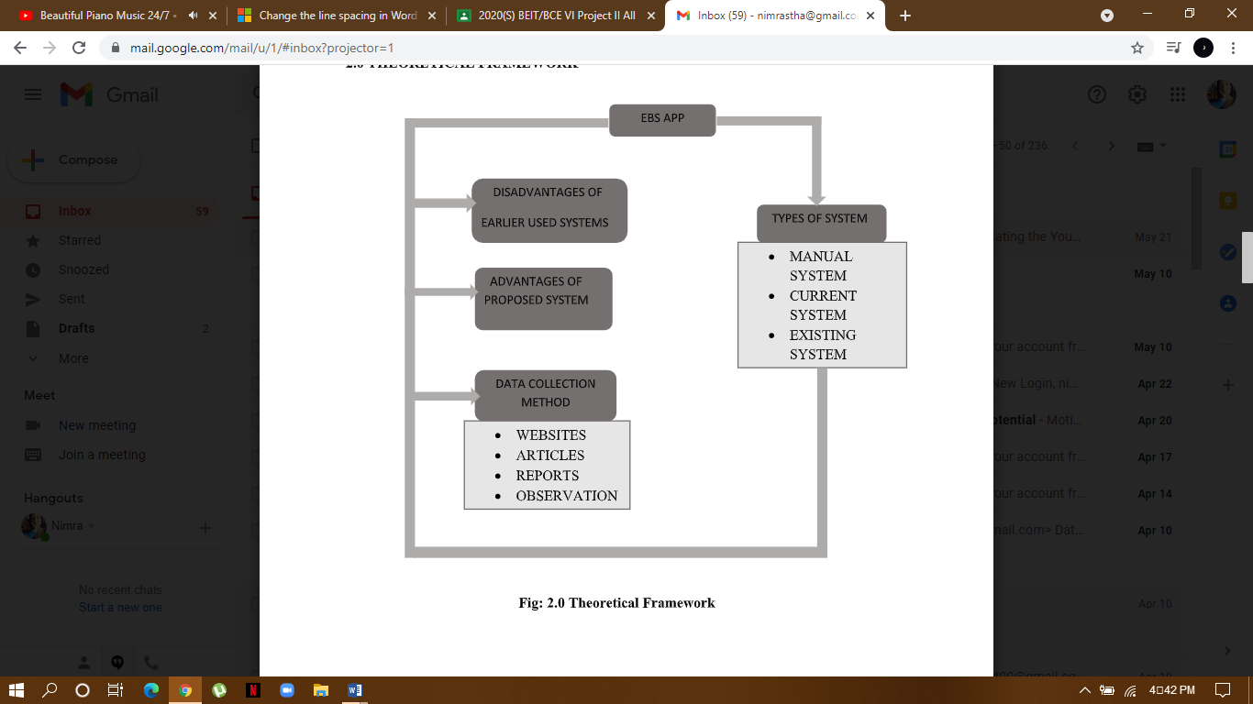

Figure 1: Theoretical Framework

**2.1 INTRODUCTION**

EBS is an electronic payment service that allows users to set up an online account to make recurring bill payments along with keeping track of their electricity consumption, past billing history and other past records such as complaints and transactions, etc. Shortly, it is an electronic way of processing electricity bill payments and maintaining records.

There are different applications that facilitates electricity billing processes.  Some of the benefits while using the online platform for electricity billing are as listed below:

1. An online transaction, billing payment is safe due to some protocols like encrypted payment process.
2. Online electricity billing procedure set the process which saves the time and as well process it in much convenient manner.
3. With online billing system, it’s easy to handle invoices, keep track of payments, etc.

**2.2 TYPES OF SYSTEM**

* **Manual System:**

Manual System In traditional monitoring, human labor which is a lineman plays a significant role in collecting and managing field data. Several of the linemen and other supporting staff are required for this manual data collection process (Anderson, 1998). The current metering system is not capable to measure variable time price and it is gradually replaced by digital or smart meters.

* **Current System:**

Nepal Electricity Authority is only the electricity utility company in Nepal. It serves over a million customers throughout the nation. NEA’s core activities are generation, transmission and distribution of electricity. Other activities include repairing, testing and maintaining hydropower, providing engineers, procurement and construction services along with power trading.

* **Existing System:**

There are several current or existing systems in the market controlled by NEA. Electricity bills can be paid online, through mobile apps and outlets of the payment gateways. The banks and financial institutions authorized for the service will set up a separate counter to collect the electricity tariff. “However, the service provider cannot charge extra from the NEA customers for the service.” Some authorized gateways are: eSewa, Paypoint, City Express Money Transfer, etc.

#### **NEA BILLING:**

NEA has launched a website from where customers can check their electricity bill amount online. However, NEA still does not have a server to accept payments directly from its customers. Thus, need to go to third party for payments.

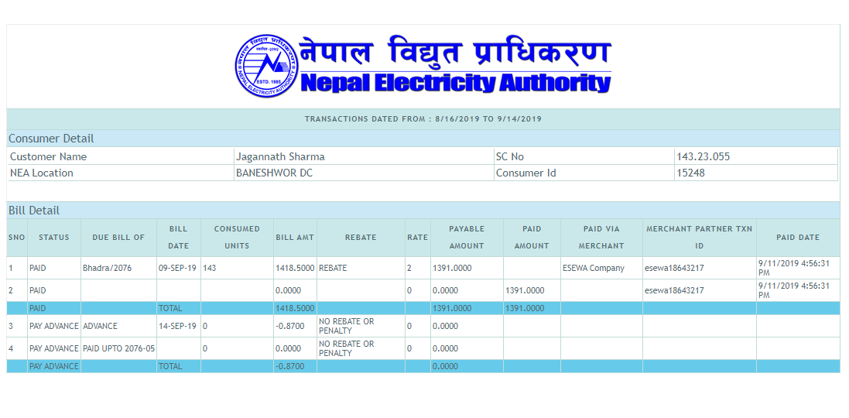

Figure 2: NEA

* + **ESEWA:**

It is a platform authorized by Nepal Electricity Authority that facilitates payment of electricity bills. It can be accessed both on web and as mobile application. It shows details of the consumer like bill date, and payable amount. However it doesn’t provide facilities as tracking electricity consumption unit of past months. One must know his/her Sc no and Consumer ID to be able to use this service.

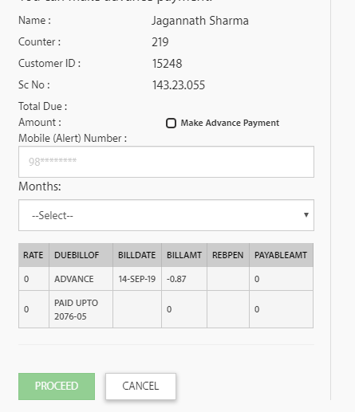

Figure 3: ESEWA

* + **KHALTI*:***

It is a wallet authorized by Nepal Electricity Authority. It can be accessed both on web and as mobile application and one must know his/her Sc no and Consumer ID to be able to use this service. However, it also is unable to track the electricity consumed in the previous month. It provides payment services through esewa, e-banking and mobile banking.

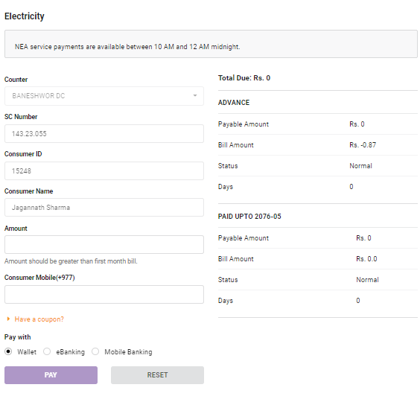

Figure 4: Khalti

## **2.4 DISADVANTAGES OF EARLIER USED SYSTEM**

### **2.4.1. MANUAL SYSTEM**

The conventional system of electricity billing is not so effective; one staff has to visit each customer’s house to note the meter readings and collect the data. Then, another staff has to compute the consumed units and calculate the money to be paid. Again, the bills prepared are to be delivered to customers. Finally, individual customer has to go to electricity office to pay their dues.

Hence, the conventional electricity billing system is uneconomical, requires many staffs to do simple jobs and is a lengthy process overall. In manual system, there may be a lot of chance of clerical and procedural errors. Its disadvantages are as follows:

* + Redundancy in stored data
  + Lack of security
* Data is inconsistent
* More time required
* Waste storage space
* Manpower required
* Errors may occur
* Regular watching and supervision is necessary

### **2.4.2. EXISTING SIMILAR SYSTEMS**

The existing online electricity bill payment systems have several demerits such as:

* They lack the ability to keep track of consumed unit and detailed transaction records.
* The NEA billing system is not able to provide payment facilities.

## **2.5 ADVANTAGES OF PROPOSED SYSTEM**

The system avoids the difficulties of the existing system. The Advantages of proposed system are -

* Tracks all the information of connections, customers, store record, bill capture, etc. and manage the information.
* Increases efficiency for managing the tracked information.
* Facilitates editing, adding and updating of records in an improvised way that results in proper resource management of electricity data.
* Provides integration of all records of customers.

# 3. METHODOLOGY

## **3.0 INTRODUCTION**

Organizations now work in quickly evolving environment with a constant need to react to new open doors, changing financial conditions and the development of contending items. Web based system is a piece of all business operations so new web application is created rapidly to exploit new open doors and to react to focused weight. Quick advancement and conveyance is hence now regularly the most basic prerequisite for programming frameworks. Indeed, numerous organizations are willing to exchange off programming quality and trade off on perquisites to accomplish speedier arrangement of system/product they require. However, as the necessities change or as perquisites issues are found, the system must be revised and rechecked. In such a situation, developing a web based system for general public (consumers), it is very important that the system undergoes continuous updates and modification in order to attract the consumers in the long run.

## **3.1 SYSTEM DESIGN**

### **3.1.1 DATA FLOW DIAGRAM**

Data flow diagram is a graphical representation of data movement, process files used in support of an information system. Unlike detail flow charts, DFDs do not supply detailed description of modules but graphically describe a system’s data and how the data interact with the system. Workflow focuses on what happens to the data through various points in the system. A data flow diagram represents the information at each processing points in the system and the direction it takes from the source and destination

To construct a data flow diagram, we use

* Arrows : identifies data flow or data in motion
* Circles: stands for a process that converts data into information.
* Open-ended boxes: represents a data source or a temporary repository of data.
* Squares: defines a source or the destination of given data.

The following information rules govern construction of DFD

1. Arrows should not cross each other
2. Squares, circles, and files must bear names.

No two data flows, squares or circles can have the same etc.

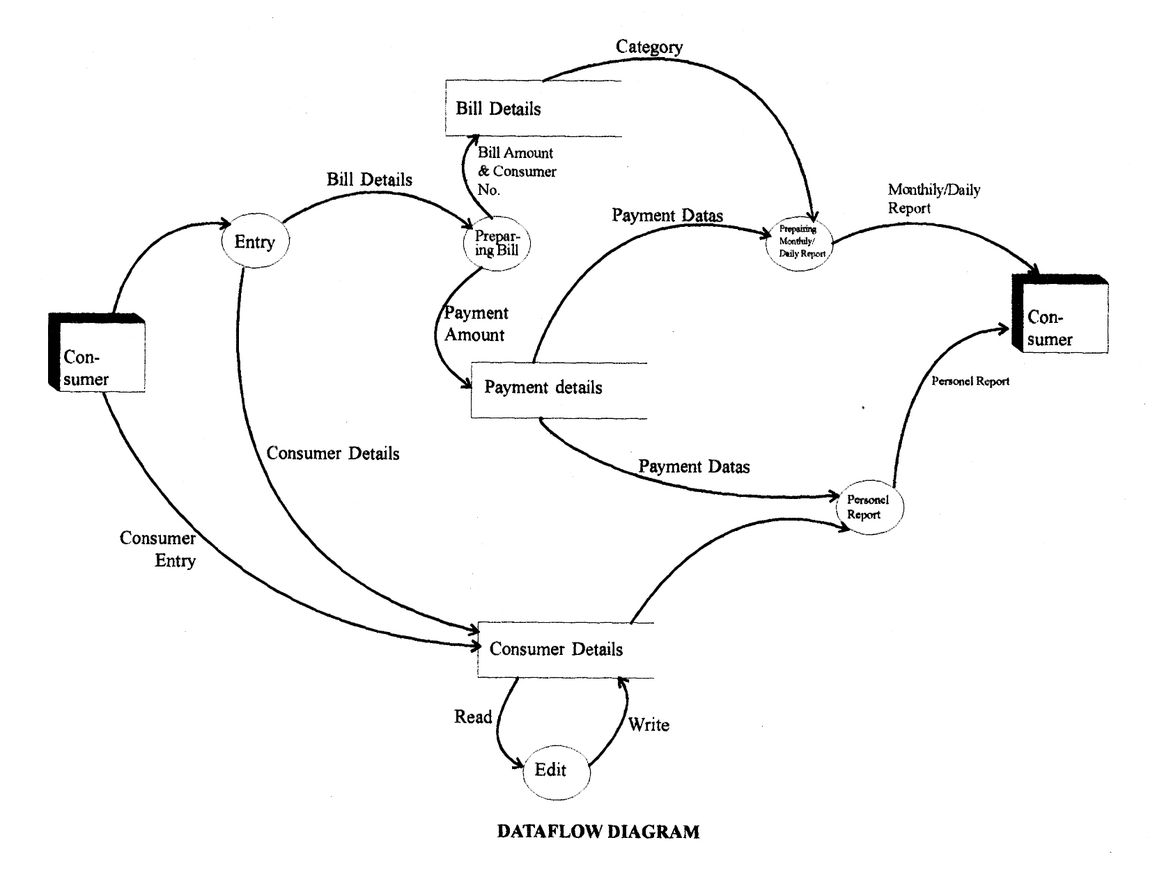

Figure 5: Data Flow Diagram

### **3.1.2 USE CASE DIAGRAM**

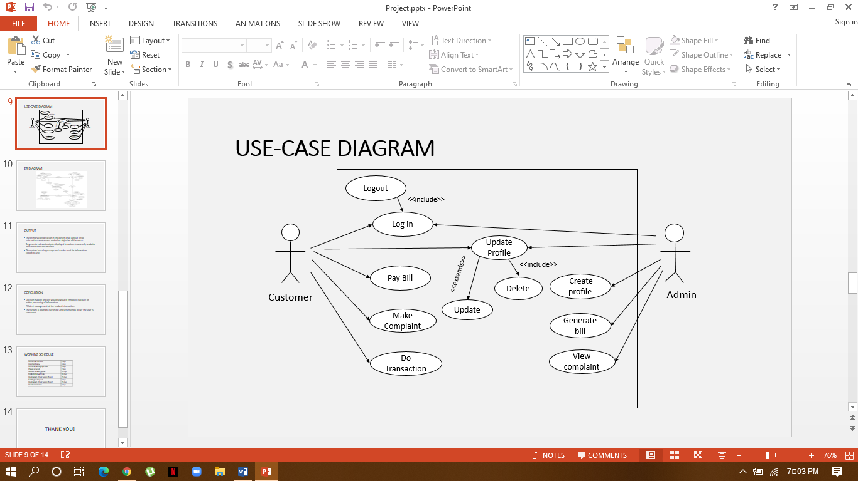

Figure 6: Use Case Diagram

### **3.1.3 ER DIAGRAM**

An entity-relationship diagram (ERD) is a data modeling technique that graphically illustrates an information system’s entities and the relationships between those entities. An ERD is a conceptual and representational model of data used to represent the entity framework infrastructure.

The elements of an ERD are:

* Entities
* Relationships
* Attributes

Steps involved in creating an ERD include:

1. Identifying and defining the entities
2. Determining all interactions between the entities
3. Analyzing the nature of interactions/determining the cardinality of the relationships
4. Creating the ERD

**Relationship Cardinality:**

The **degree of relationship** (also known as cardinality) is the number of occurrences in one entity which are associated (or linked) to the number of occurrences in another. The cardinality of the relationship describes the number of tuples on each side of the relationship.

The degrees of relationship are:

* 1 : 1 – one to one
* 1 : N – one to many
* N : 1 – many to one
* N : N – many to many

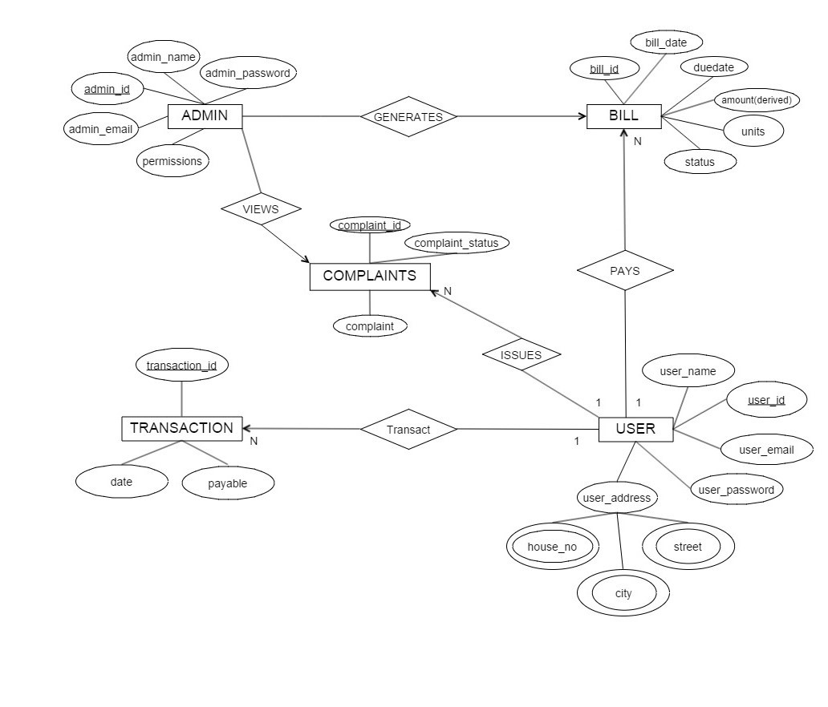

Figure 7: ER Diagram

# 4. WORK PROGRESS

## **4.0 Work Completed**

We have so far completed our login/registration page and menu page and see forward to finish the remaining project by end of this month.

There are mainly two types of users of the system. They are:

* Admin
* Consumers ( General people )

### **4.0.1 Snapshots**

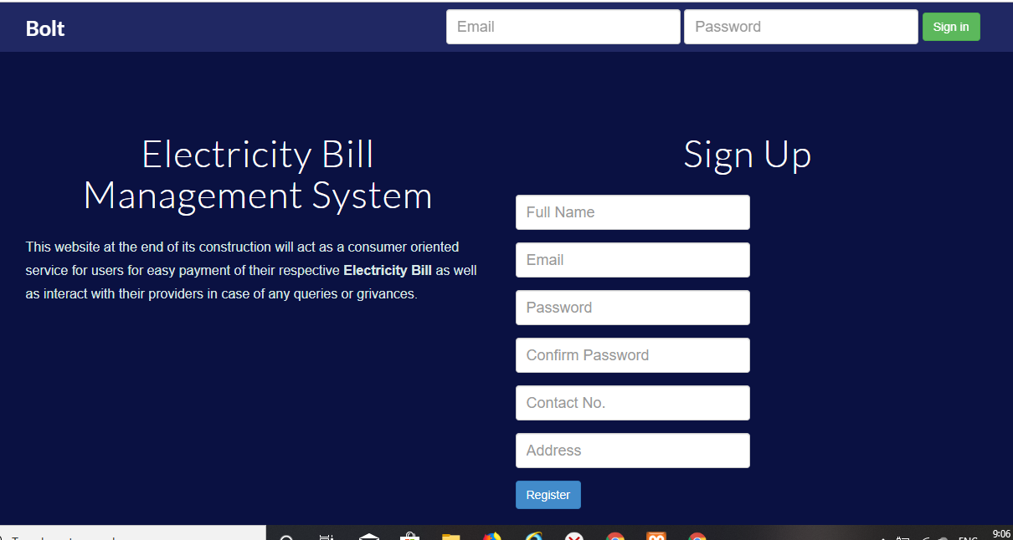

Figure 8: Login / Signup Page

* **HOMEPAGE**

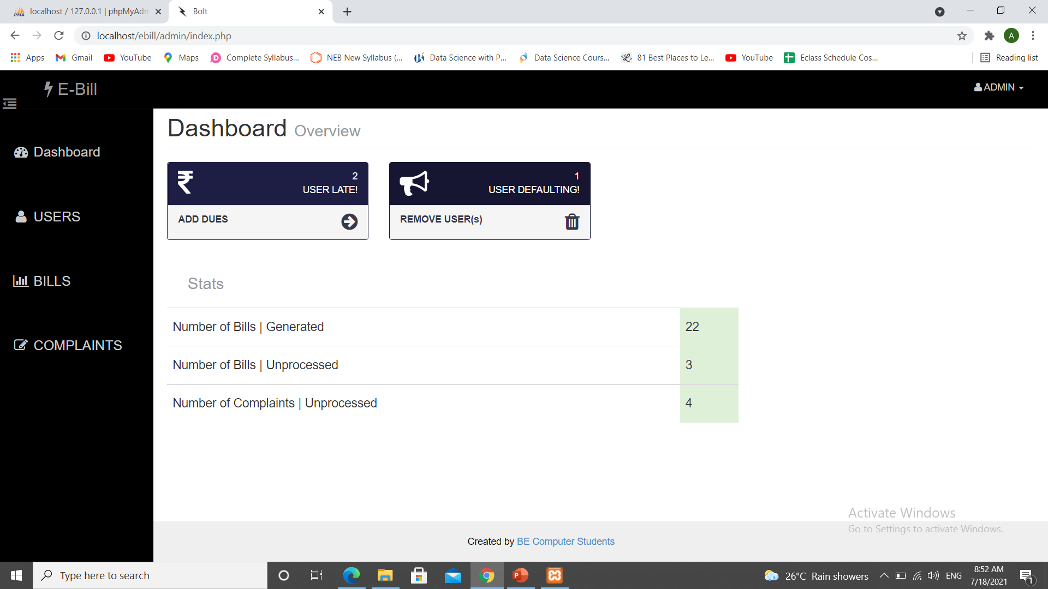

Figure 9: Homepage of Admin Panel

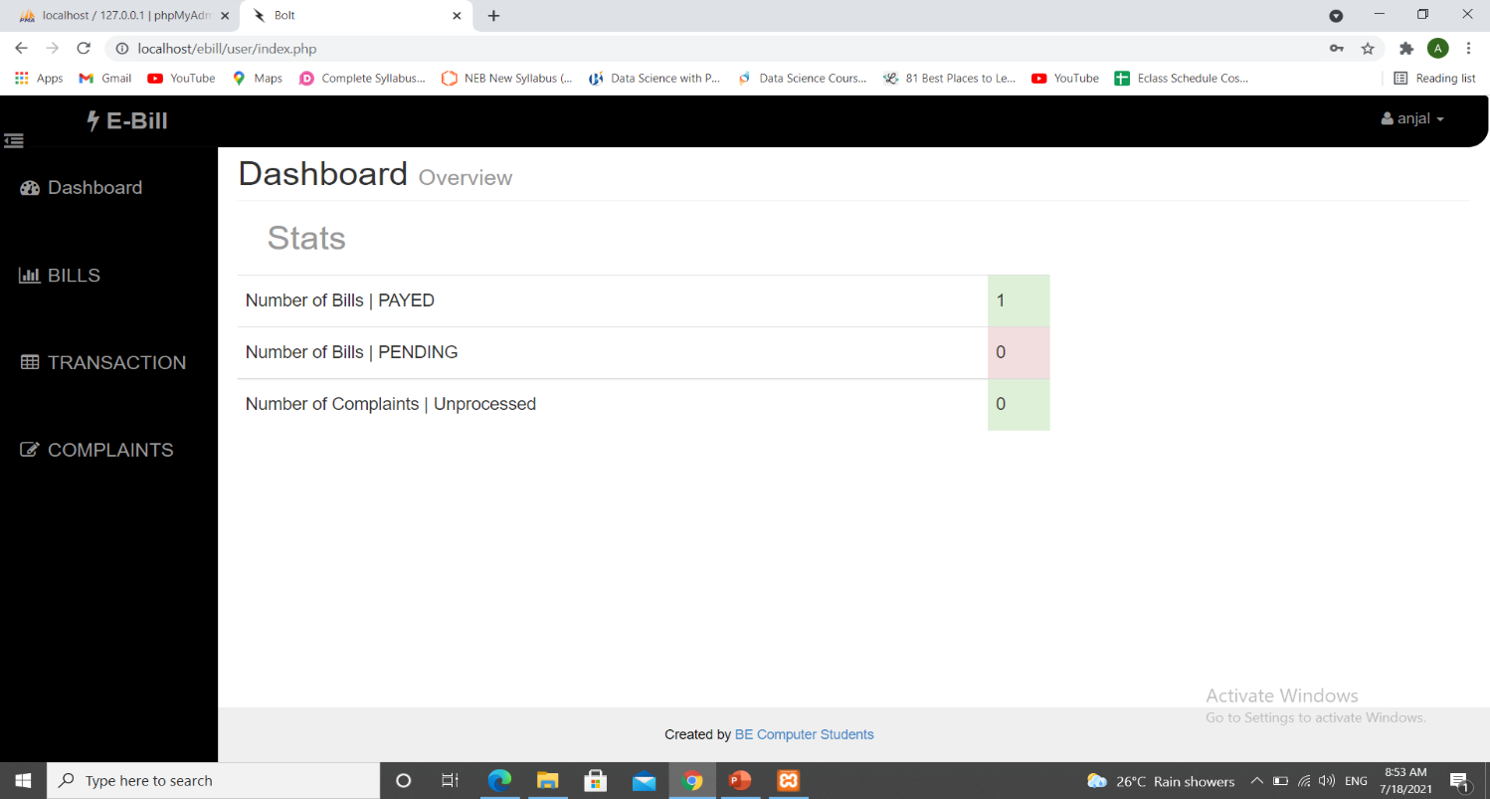

Figure 10: Homepage of User Panel

## 4.1 Work to be done:

To include everything from billing system to information collection in a system is a challenging task. However, our aim for the future research is testing the system with new data as well as adding facility of payment such as esewa or i-banking in the website as providing direct payment will be very handy once implemented.

# **5. WORK SCHEDULE**

Figure 11: Gantt Chart showing Work Schedule

# 6. REFERENCES

[1] *‘Electricity Billing System’ retrieved from*

*https://www.scribd.com/document/133997396/Energy-Billing-System-Full-Documentation*

[2] *‘Project Management Methodologies ‘retrieved from*

*https://www.tutorialspoint.com/management_concepts/project_management_*

*methodologies.htm*

[3] *‘Electricity Billing System’ retrieved from*

[*http://asset-0.soup.io/asset/10154/6783_0d5d.pdf*](http://asset-0.soup.io/asset/10154/6783_0d5d.pdf)

[4] *‘Electricity online bill payment’ retrieved from*

[*https://nevonprojects.com/electricity-online-bill-payment-project/*](https://nevonprojects.com/electricity-online-bill-payment-project/)